Gallery Page

Definition
# Source: AI Source: Provided by: [Data Path: Persons Table -> ID Column: 1, Name_En Column: Motasem Essam] -> From: [Chatgpt (GPT‑5 Mini)] on [2/12/2026]
A Gallery Page is a web page used to display images, photos, videos, or other visual content in an organized and attractive layout.

Simple Definition
# Source: AI Source: Provided by: [Data Path: Persons Table -> ID Column: 1, Name_En Column: Motasem Essam] -> From: [Chatgpt (GPT‑5 Mini)] on [2/12/2026]
Gallery Page = a page that shows a collection of pictures or media.

What a Gallery Page Usually Includes
# Source: AI Source: Provided by: [Data Path: Persons Table -> ID Column: 1, Name_En Column: Motasem Essam] -> From: [Chatgpt (GPT‑5 Mini)] on [2/12/2026]
- Image thumbnails – small preview pictures
- Full-size view – click to open larger image or video
- Grid or slideshow layout – organized display of media
- Captions / descriptions (optional) – info about each image
- Categories / filters (optional) – sort by type or topic

Purpose of a Gallery Page
# Source: AI Source: Provided by: [Data Path: Persons Table -> ID Column: 1, Name_En Column: Motasem Essam] -> From: [Chatgpt (GPT‑5 Mini)] on [2/12/2026]
- Showcase visual content clearly and beautifully
- Highlight work, products, or events
- Make browsing images easy for visitors

Examples
# Source: AI Source: Provided by: [Data Path: Persons Table -> ID Column: 1, Name_En Column: Motasem Essam] -> From: [Chatgpt (GPT‑5 Mini)] on [2/12/2026]
- Photographer website → photo collections
- Business website → product images or completed projects
- School website → event photos
- Travel blog → trip pictures

Difference Between Gallery Page and Portfolio Page
# Source: AI Source: Provided by: [Data Path: Persons Table -> ID Column: 1, Name_En Column: Motasem Essam] -> From: [Chatgpt (GPT‑5 Mini)] on [2/12/2026]
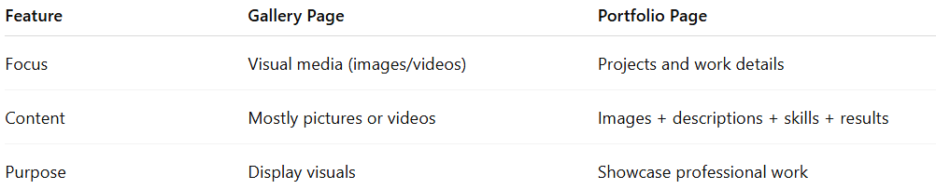
Feature | Gallery Page | Portfolio Page
Focus | Visual media (images/videos) | Projects and work details
Content | Mostly pictures or videos | Images + descriptions + skills + results
Purpose | Display visuals | Showcase professional work

